**Screenshot of Step-5**

**Split1_Confusion_matrix_SVM (Run 1):**

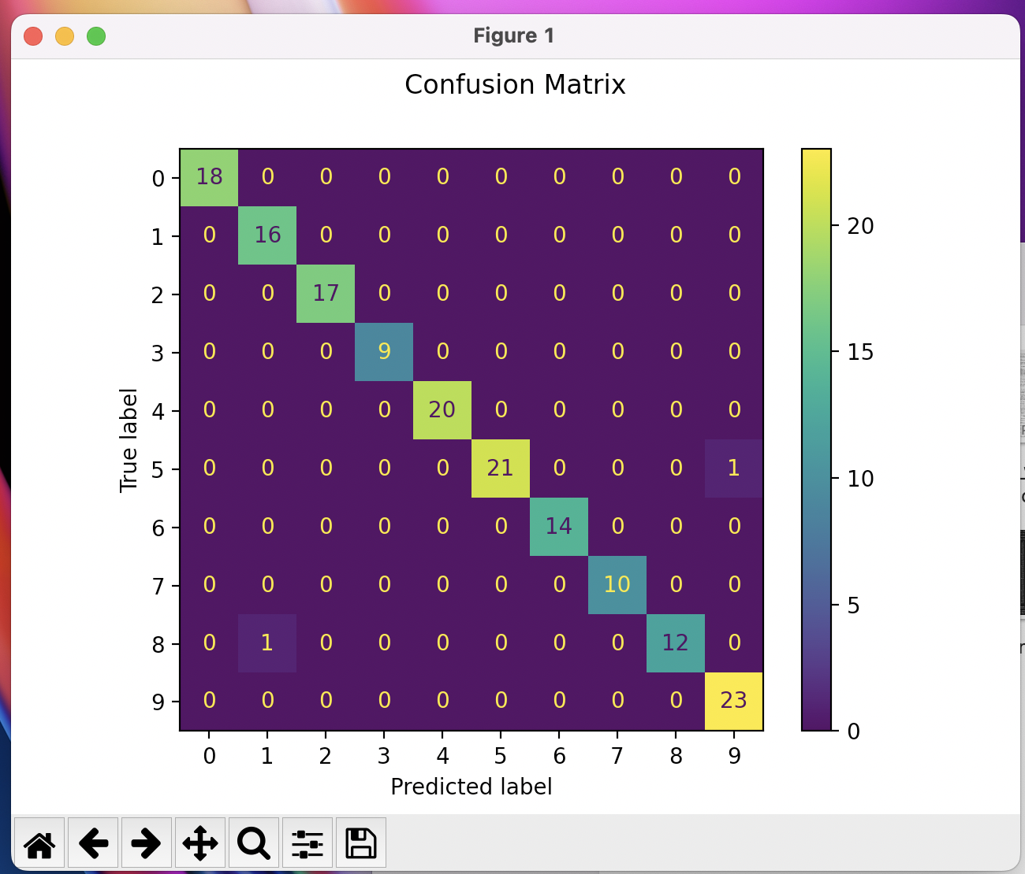

**Split1_Confusion_matrix_Decision_Tree (Run 1):**

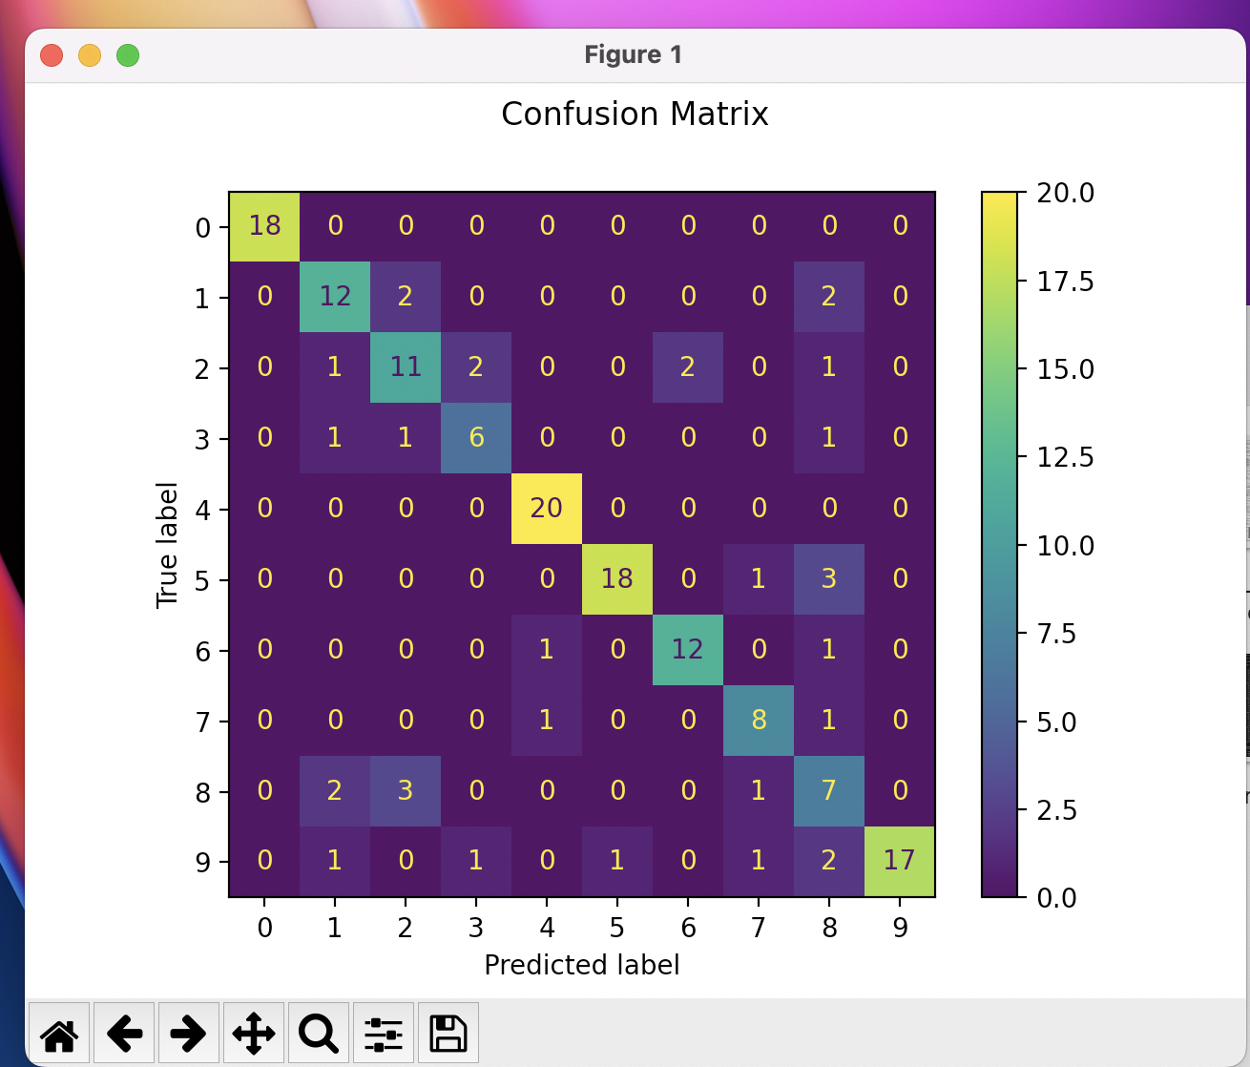

**Split2_Confusion_matrix_SVM (Run 2):**

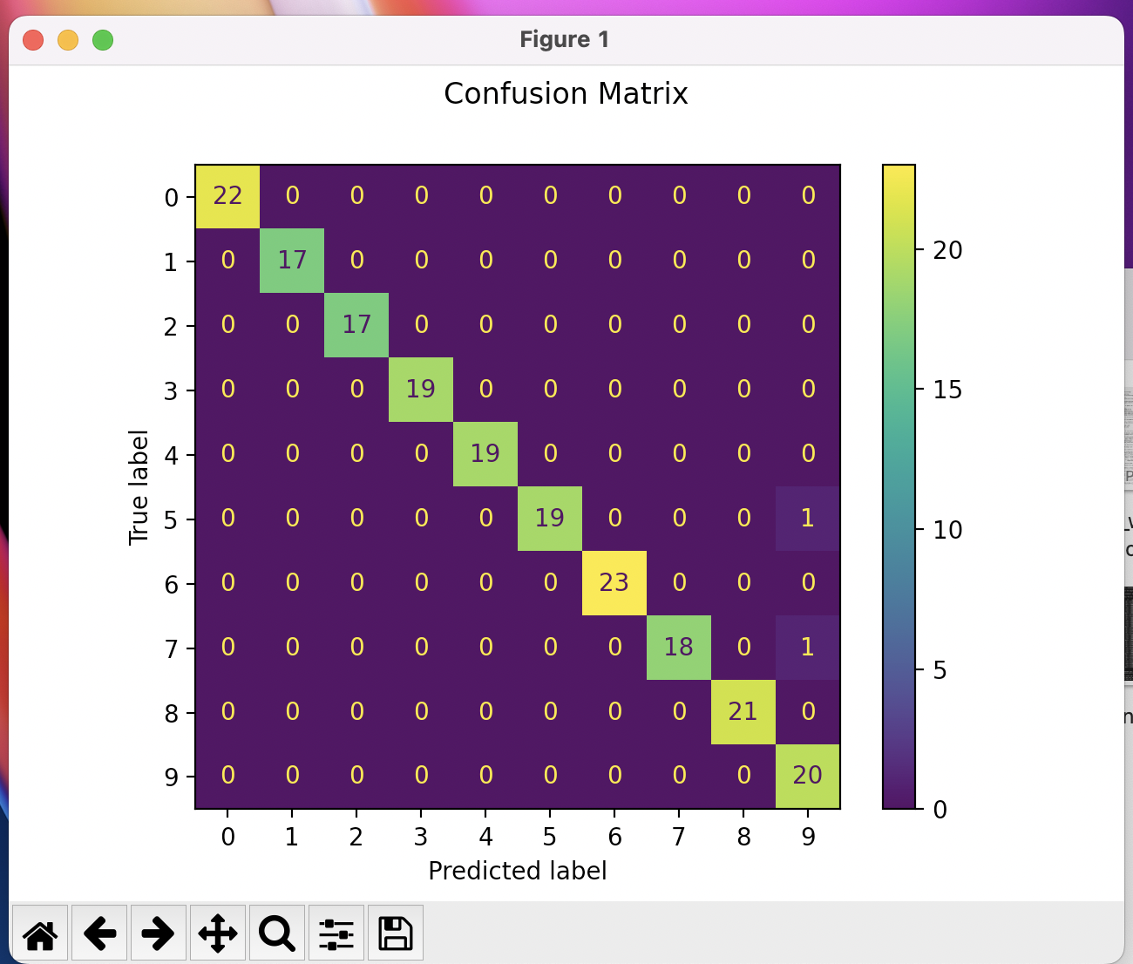

**Split2_Confusion_matrix_Decision_Tree (Run 2):**

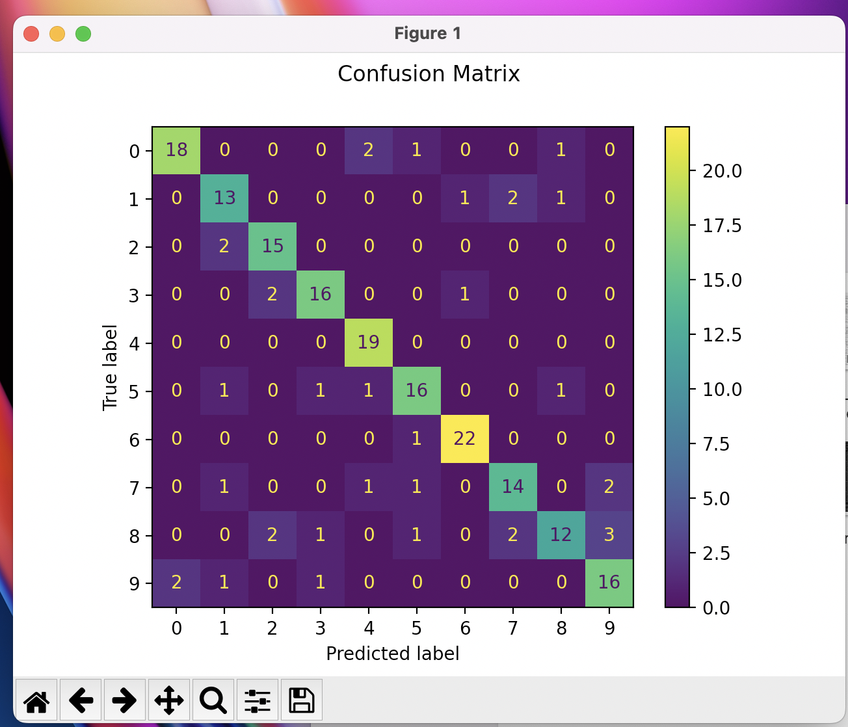

**Split3_Confusion_matrix_SVM (Run 3):**

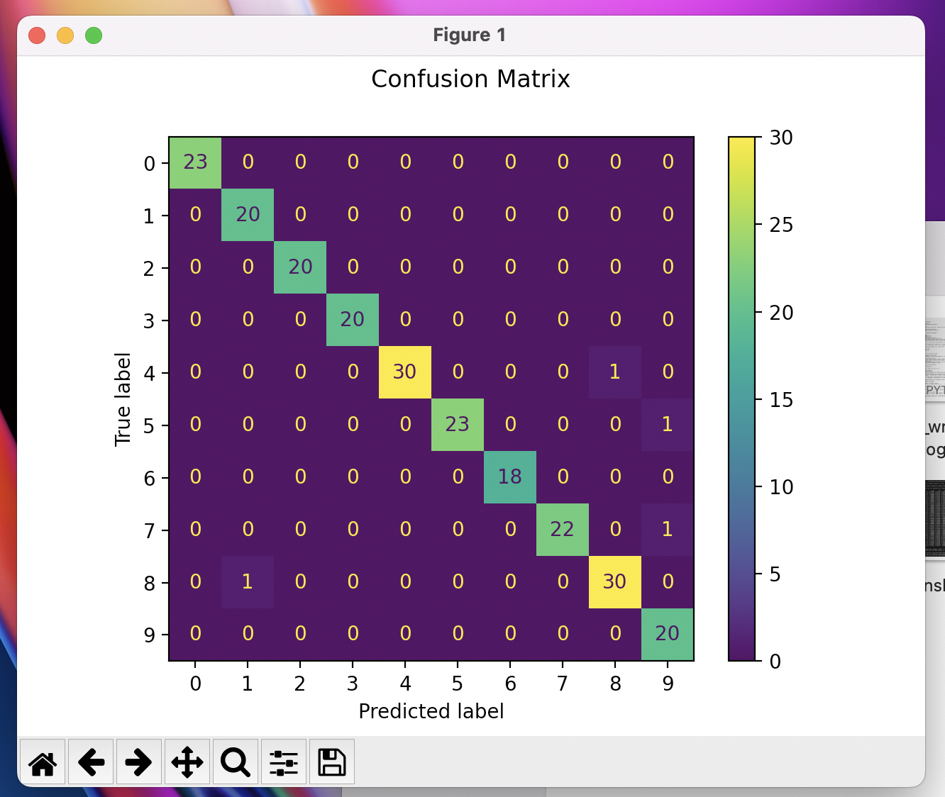

**Split3_Confusion_matrix_Decision_Tree (Run 3):**

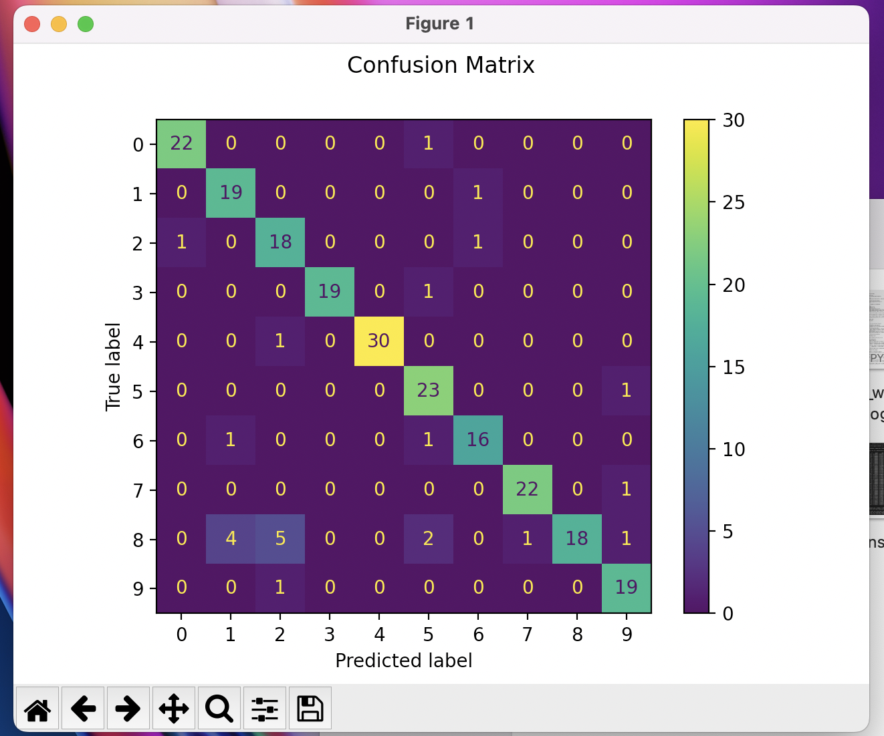

**Split4_Confusion_matrix_SVM (Run 4):**

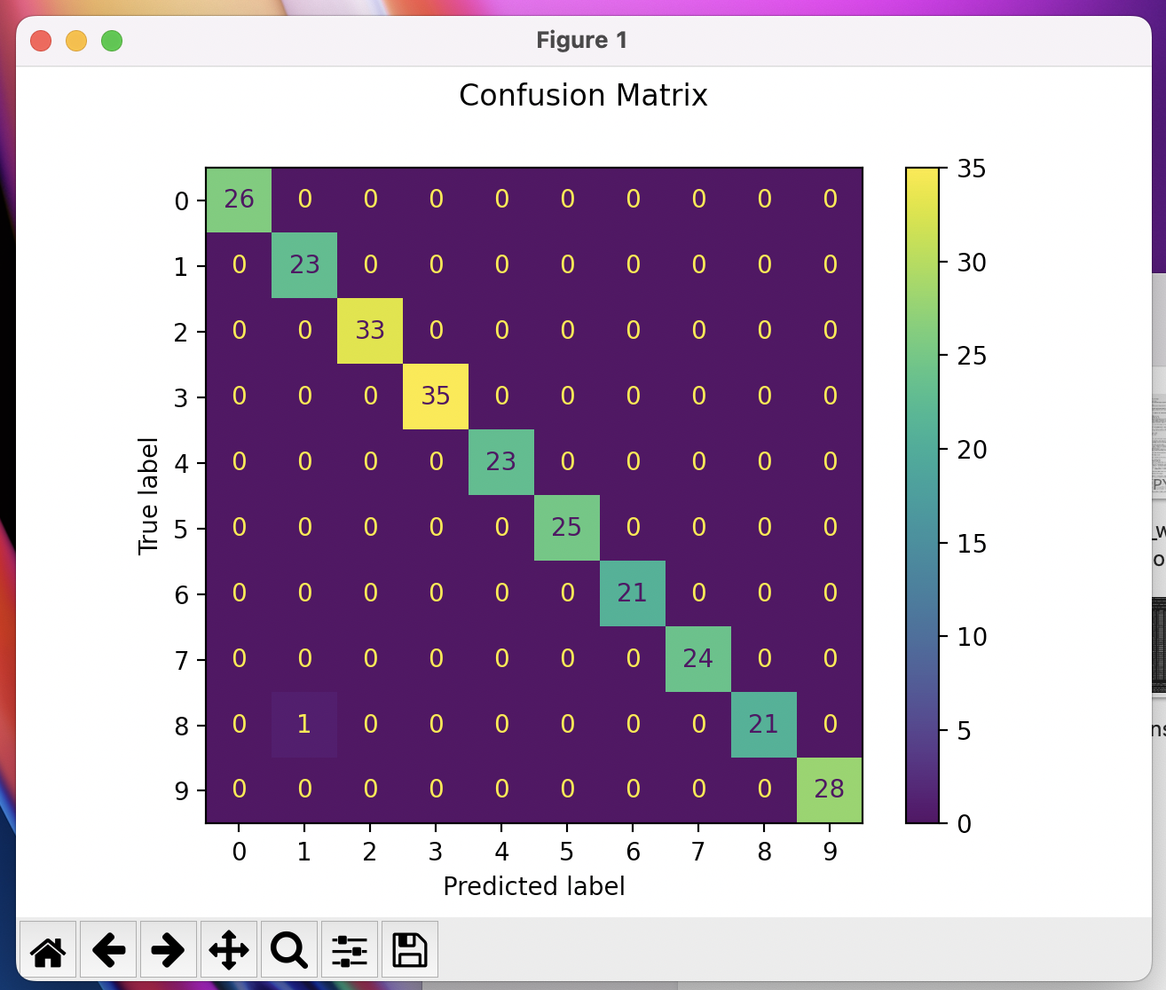

**Split4_Confusion_matrix_Decision_Tree (Run 4):**

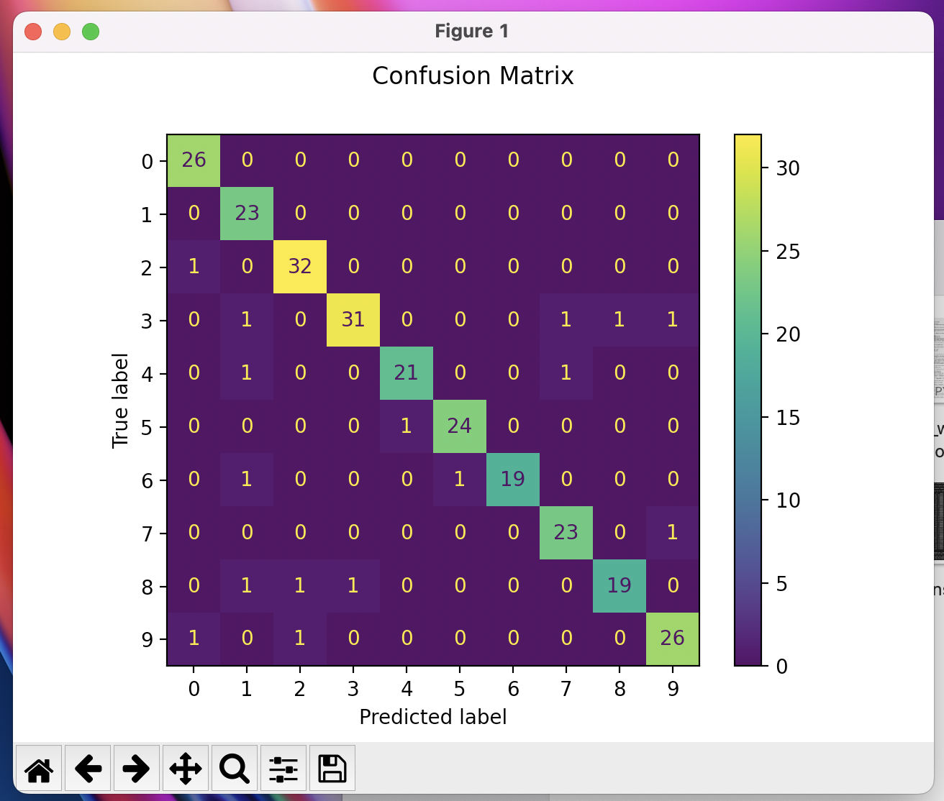

**Split5_Confusion_matrix_SVM (Run 5):**

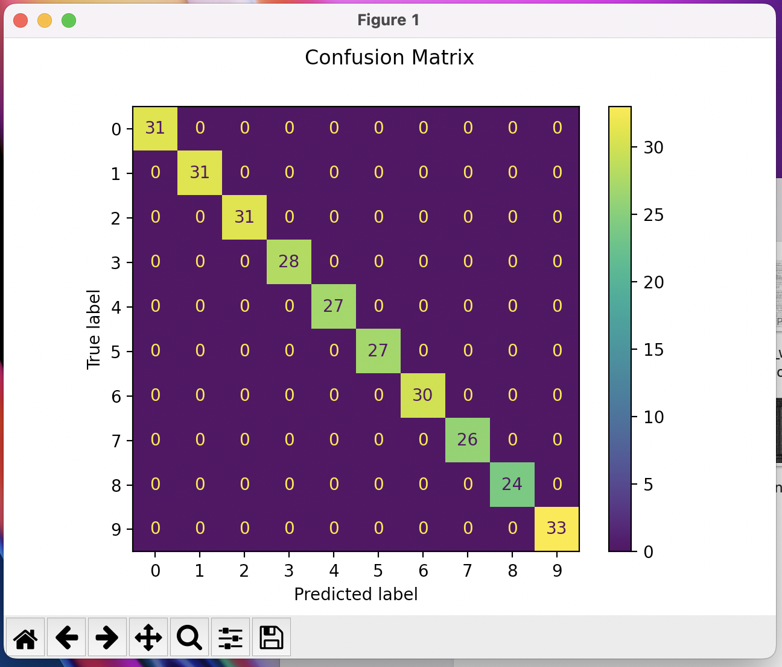

**Split5_Confusion_matrix_Decision_Tree (Run 5):**

